Message from the Honorable Minister and the Chairman.
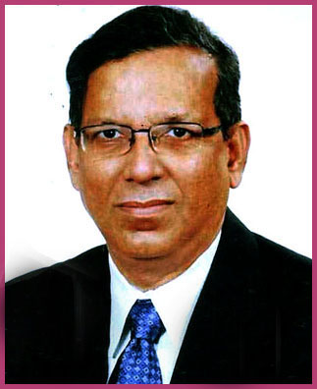

The Constitution of Bangladesh guarantees equal rights for all citizens irrespective to sex, race, religion, ethnicity and wealth. All are equal before law and are enjoyed equal rights and equal protection of law. To provide the best possible legal aid services to the insolvent, destitute, helpless and distress people of Bangladesh, the Government of Bangladesh has established National Legal Aid Services Organization under the provision of Legal Aid Services Act, 2000. Through various committees and forums at national level to grassroots, the Organization now reaches justice to the door steps of the poor and aggrieved people.
I appreciate the momentum to provide legal aid services is in progress and hoping the endeavor will yield positive changes in the lives and livelihood of the destitute and disadvantaged people.
I hope through this website, regular flow of relevant information and transparency and accountability will be ensured and the people of Bangladesh will learn and be aware on legal aid interventions which will ultimately leads to equal and timely service delivery for all.

Anisul Huq

Minister
Ministry of Law, Justice and Parliamentary Affairs
People’s Republic of Bangladesh.

